NEXTAG COMPANY

**GG Marmont leather pouch**

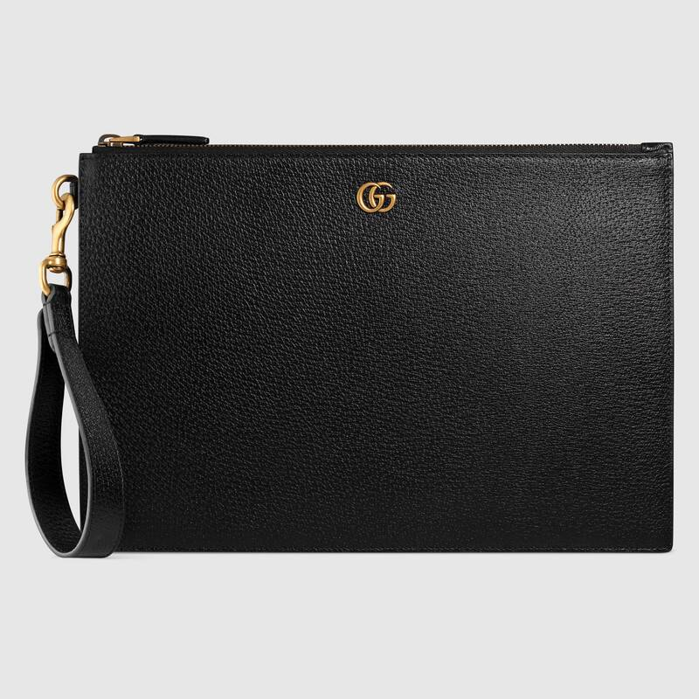

Style # 475317 DJ20T 1000

Product Description

A slim leather pouch, distinguished by Double G hardware. Made in calfskin leather

heat-stamped to achieve a boar effect, giving it a textured appearance.

GG Marmont • Removable leather wrist strap • Six card slots and one open pocket • Zipper closure • Made in ItalyPresented in black and grey GG Supreme canvas, this iPhone case is completed by a removable wrist strap. Tigers, reflecting the fascination for wild animals that permeate the House's narrative, contrast the monogrammed background.

* Black/grey GG Supreme canvas with tigers print, a material with low environmental impact
* Black leather trim
* Moiré lining
* Two card slots
* Removable wrist strap with 4.9" drop
* Zipper closure
* 7"W x 4.3"H
* Made in Italy

Presented in black and grey GG Supreme canvas, this iPhone case is completed by a removable wrist strap. Tigers, reflecting the fascination for wild animals that permeate the House's narrative, contrast the monogrammed background.

* Black/grey GG Supreme canvas with tigers print, a material with low environmental impact
* Black leather trim
* Moiré lining
* Two card slots
* Removable wrist strap with 4.9" drop
* Zipper closure
* 7"W x 4.3"H
* Made in Italy

PRODUCT DETAILS

Style ‎475317 DJ20T 1000

A slim leather pouch, distinguished by Double G hardware. Made in calfskin leather heat-stamped to achieve a boar effect, giving it a textured appearance.

* Black leather
* Removable leather wrist strap
* Six card slots and one open pocket
* Zipper closure
* 12"W x 8"H x .6"D
* Made in Italy